

UNISYS LIMITED
Information Services Group
COMPASS GROUP
In-Unit Trading System (IUTS)
‘C’ & ‘C++’ Coding Standards
Authorised for issue by:

R Teychenne
Unisys Programme Director Signature Date

This document is issued by Information Services Group, Unisys Ltd on a controlled copy basis. This copy has been issued to:

Proprietary Data

The information contained in this document is proprietary to Unisys Limited and Unisys Corporation. The information in this document is not to be reproduced, shown or disclosed outside Commercial SI without the express written permission of the Lead Principal, Commercial SI, Unisys Limited or his nominated representative.

This document is the property of and shall be returned to:

Commercial SI
Unisys Limited
31 Brentfield
Stonebridge Park
London NW10 8LS.

Copyright (C) 1995 Unisys Limited, 31 Brentfield, Stonebridge Park, London NW10 8LS.

The information contained herein is subject to change. Revisions will be issued to controlled copy holders to advise of any changes and/or additions.

Correspondence regarding this publication should be addressed directly to the Lead Principal, Commercial SI, Unisys Limited, 31 Brentfield, Stonebridge Park, London NW10 8LS.

Change Summary

Version | Date | Section | Description of Change
Draft A | 24/4/96 | All | Initial version.
Version 1.0 | 5/6/96 |  | Version for review and signature

1. TITLE

‘C’ and ‘C++’ Coding Standard.

2. REFERENCES

[1] The C Programming Language, Second Edition, Brian W. Kernighan & Dennis M. Ritchie, Prentice Hall, 1988.

[2] Portable C Software, Mark R. Horton, Prentice Hall, Englewood Cliffs, NJ, 1990.

[4] The C++ Programming Language, Second Edition, Bjarne Stroustrup, Addison-Wesley, 1994.

[5] Effective C++: 50 Specific Ways to Improve Your Programs and Designs, Scott Meyers, Addison-Wesley 1992.

[6] Win32 Programming Using Visual C++, Mike Blaszczak, Wrox, 1995.

3. PURPOSE

The purpose of the Compass ‘C’ and ‘C++’ Coding Standards is to define a common set of guidelines for all ‘C’ and ‘C++’ software developed for the Compass In-Unit Trading project.

All ‘C’ and ‘C++’ code for the Compass In-Unit Trading project will be written to the standard defined in this Local Practice.

The local practice covers aspects of the use of development tools, naming conventions, coding style, source documentation and portability.

This Local Practice is written to ensure that all programmers produce software which conforms to a similar style/standard making it easier to maintain, enhance and support the software even when the original authors are not available to the project.

4. SCOPE

This standard applies to all ‘C’ and ‘C++’ code written for the Compass In-Unit Trading project.

It extends those standards and conventions described in the Visual Basic programmers documentation (the major references are given above). See also the comment on tool standards below.

The local practice will be updated should additional Compass specific coding standards be developed (beyond those defined herein).

5. DESCRIPTION

The standard for the ‘C’ and ‘C++’ code is detailed below:

5.1 Definitions And Acronyms

The following acronyms are used in this document:

ANSI American National Standards Institute.
K&R Kernighan & Ritchie.

- Software Development Tools

5.2.1 Source Control and Configuration Management

All source files for the Compass project must be maintained by the PVCS Source Code Control tool. This includes source code for DOS, Windows 3.11, Windows 95 and Windows NT Microsoft ‘C’ and Visual ‘C++’ development.

5.2.2 The Compiler

For DOS development, the Microsoft ‘C’ compiler must be used. For Windows 3.11, Windows 95 and Windows NT development, the Microsoft Visual ‘C++’ compiler must be used.

There have been three major definitions of the ‘C’ language in use recently: the first edition of Kernighan and Ritchie's The ‘C’ Programming Language (K&R); the ‘C’ compilers on major implementations of the UNIX system such as SVR2; and the ANSI ‘C’ standard.[1]

All ‘C’ code developed for the Compass project must conform to the ANSI standard defined by the ANSI X3J11 committee.

Refer to the Configuration Management Plan for current versions of ‘C’ and ‘C++’ compilers.

For Microsoft Visual ‘C++’, in the project settings C/C++ tab enter _STDC_ in the preprocessor definition of the preprocessor category as the compiler option for ANSI ‘C’ compatibility and always take "-l" option to build the large executable model.

All ‘C++’ code must conform to the AT&T 2.1 language specification (or later) [4].

All code must be compiled with no compiler warning messages. Warnings must be eliminated by changing the source, rather than setting compiler options to suppress the warnings. Most warnings in ‘C’ code are caused by making assignments to objects of different type. This is allowed in ‘C’, and the use of casts will avoid the warning message. However, consistent use of types will reduce the amount of casting required to a minimum.

5.2.3 Automated Build Utilities

For Windows NT, the Microsoft Visual ‘C++’ automated project build utility should be used [6]. The option to convert to a standard makefile must not be chosen.

5.3 Naming Conventions

5.3.1 File Names

Files must be named according to the following suffix rules:-

‘C’ source files .C
‘C++’ source files .CPP
‘C’ source header files .H
Resource files .RC
Object files .OBJ
Library files .LIB
Assembly files .ASM

‘C’ source files that contain main() must have the word main in the file name.

5.3.2 Program Identifiers

ANSI ‘C’ restricts internal names to a maximum of 31 significant characters, and 6 characters for external names. The reason for the 6 is because of restrictions with symbol tables in some old linkers.

Function names must generally be verbs which describe the function they perform. e.g. getprotobyname(), setsockopt() etc.

All program identifiers must be meaningful. The only exception here is loop control identifiers such as i, j, k etc. To enhance readability, identifiers should not have more than one consecutive underscore.

#define constants and macros must be in upper case.

All variables and function names must be in lower case. Variable names should not begin with a lower case p character. Only pointer variables must begin with the character p. Pointers to pointers must begin with pp.

Literals in ‘C’ code must be defined with ‘#define’ constants.
Literals in ‘C++’ code must be defined with ‘const’ or ‘enum’ declarations.

Structure names must have the suffix _s.
Typedef names must have the suffix _t.
Union names must have the suffix _u.
Class data members must have the prefix m_.

5.4 Source Code Layout

5.4.1 ‘C’ Source Code Layout

The style of ‘C’ programs must be consistent with the output of the ‘C’ Beautifier (cb) generally available under UNIX. This will ensure that the indentation, spacing, positioning of opening and closing braces etc. is consistent.

Source code must be formatted to a tab value of 4 characters.

The opening and closing braces of a block must always be on a line on its own as shown in the example below:

if (colour == C_RED)
{
statement();
statement();
}

The source code layout for flow control and loop constructs is defined by the K&R style.

“if (colour == C_RED)”

The flow control source code is an example of opening and closing braces of a block. It is not intended as an example layout of the “if” control construct.

Each block level of a ‘C’ program must be indented by a tab position. Statements within a ‘case’ of a ‘switch’ statement must also be indented one level as shown below.

switch (colour)
{
case C_RED:
statement();
break;
case C_GREEN:
statement();
break;
default:
statement();
}
Access specifiers must be indented to the same level as the enclosing block as shown below.

class my_class
{
private:
int m_data;
public:
int get_data();
};
Single statement functions such as access or forwarding functions may be declared and defined on the same line e.g.

class my_class
{
...
const int get_data(){ return &m_data; }
...
const void print_data(){ return m_data.print(); }
...
};

Multi-statement functions defined in the class declaration must have each statement on a separate line in the usual way. Functions with more than three statements must not be defined in the class declaration.

Lines of source code must not exceed 80 columns.

Source files must not be greater than 1000 lines.

Source code must only contain ASCII printable characters, and ‘newline’ characters. New page characters and other binary control characters must not be present.

5.4.2 Windows Code Layout

‘C’ and ‘C++’ source code layout for the Windows NT environment is as defined by the default options of the Microsoft Visual ‘C++’ development environment.

.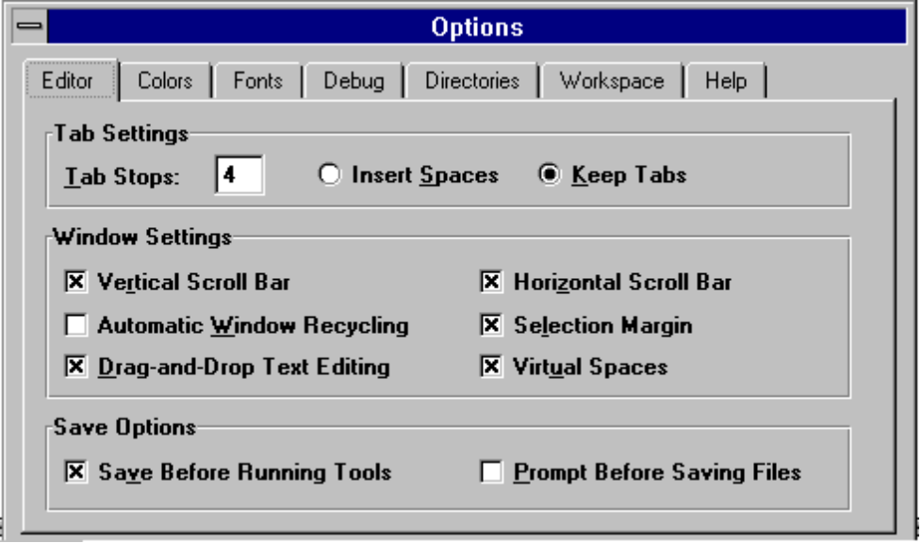

The colours of the language-aware editor should be set to black on a white background except for the following.

 | Foreground colour | Background colour
Disassembly window | Grey
Registers highlight | Red
Memory highlight | Red
Calls highlight | Black | Green
Breakpoint | White | Brown
Current statement | Black | Yellow
Current error/tag | White | Blue
Bookmark | Black | Light blue
Text selection | White | Black
C Keywords | Blue
C++ keywords | Blue
Comment | Green
User defined types | Blue

Where no guidance is given by default options of the Visual ‘C++’ environment, ‘C’ guidelines for code layout should be followed as defined in section 5.4.1.

5.5 Source Code Documentation

5.5.1 Source File Headers

Source code file headers must be used in all ‘C’ and ‘C++’ source files.

The following information must be given:

- System Name (e.g. COMPASS).
- The language e.g. ANSI C.
- The operating system including a note of any dependencies on particular O/S versions.

- Configuration item identification

- Creation date : $Date$

- Author : $Author$

- Pathname : $Smspath$

- Description of the program/module.

An example header is given in Appendix A.

5.5.2 Function Headers

Function documentation must include the following information:

- Function name.

- Configuration item identification

- Creation date : $Date$

- Author : $Author$

- Pathname : $Smspath$

- Description.
- Description of parameters.
- Description of the return value.
- List of any external variables used.

An example function header is given in Appendix B.

5.5.3 General Comments

Code should be commented sufficiently for any developer to comprehend, i.e. a description of the purpose of the routine, a full description of external inputs and outputs, the purpose of loops, etc.

In addition to source file headers and function headers, two other types of comments must be used in source files, these are line comments and block comments.

Line comments are a single line of comment text which must follow a line of source code as shown below.

char env_user[MAX_EUSER]; /* user environment variable */

Block comments which regardless of the number of lines, must be formatted as follows:

/*
* Single line comment
*/

/*
* Multiple lines of
* comment
*/

‘C++’ code must use ‘C++’ style comments i.e. line comments must be of the form:

char env_user[MAX_EUSER]; // user environment variable

‘C++’ block comments must be formatted as follows:

//
// Single line comment
//

//
// Multiple lines of
// comment
//

All function declarations in a program must have a line comment to say where the function is defined. Function declarations will apply to all non int functions that are not declared in standard header files.

All ‘C’ function declarations in header files must be ‘C++’ compatible. This is easily achieved by preceding each declaration with statements of the form:

extern
#ifdef _cplusplus
"C"
#endif

Function declarations must use the ANSI style, that is to say that formal argument types must be given in the declaration. Return type should always be specified.

- Code Optimisation

Use the standard compilation and do not optimise using a compiler.
5.6 Program Usage Information And Error Messages

All COMPASS command line executables must display Usage information to stderr in the following situations:

- If the syntax or semantics of the given parameters are incorrect.
- If the user specifies the -h option (for help).

The Usage information must be displayed as in the following examples:

Usage: namsrv [/h] [/i n.n.n.n ] [/p n] [/t n] for DOS
where, h display usage information
i IP address
p TCP port number
t set trace level to n (default 3)

Note that there is a TAB character between the option letter and the description.

For consistency in the COMPASS project, the following option letters must always be used for the popular options.

- IP addresses must always use the -i option and must be specified by -i n.n.n.n.
- TCP port numbers must always use the -p option and must be specified by -p n, here n is the decimal representation of the TCP port number. For software that acts as a TCP listening daemon, a default (well known) port number must always be used. This number must be shown as the default in the usage information.
- Trace levels must always use -t option and must be specified as -t n. The default must be 3. Higher numbers produce more verbose output.
- Usage information must always use -h.

All error messages to the user terminal must be written to stderr and be preceded by the program name followed by a colon followed by a space followed by the error message. For example:

fprintf(stderr, "%s: failed to open namsrv.in, errno=%d\n",
argv[0], errno);
5.7 Portability Considerations

5.7.1 Hardware Dependencies

No assumptions should be made about the byte ordering within a machine word, or about the word ordering of long variables. Different machines behave differently in this respect.

The int type in ‘C’ is generally the size of the natural word of the machine architecture in use. For software that requires fixed sizes for variable definition, typedefs should be used from a central header file which can be set up for each machine type. e.g.

typedef unsigned int uint16_t;

The ANSI ‘C’ standard has defined a header file containing definitions of machine limits which can be used as an aid to portability. It is called <limits.h>.

Some processors require that certain kinds of data be aligned on 2, 4, 8 or even 16 byte boundaries. For this reason, the ‘C’ Compiler is free to leave gaps in memory to force correct alignment. The size of a given ‘C’ structure may therefore vary in size depending on the machine type.

5.7.2 ‘C’ Language Dependencies

The ANSI ‘C’ definition states that all global variables are initialised to zero, unless otherwise initialised. Some ‘C’ Compilers also initialised stack variables on function entry. Programs must always assume that stack variables are uninitialised, and could therefore contain random values.

The book Portable C Software by Mark Horton [2] discusses the whole issue of portability, with particular reference to DOS and UNIX.

5.8 ‘C++’ Classes

A copy constructor and an assignment operator must be declared for classes with dynamically allocated memory. They need not be defined but will prevent errors caused by the compiler generated defaults. A virtual destructor must be defined for all base classes.

Member data must not be public. Public member functions must not return a non-const pointer or reference to member data.

‘Const’ must be used wherever possible both for functions and their parameters. ‘Const’ reference parameters must be used rather than pass by value for all parameters other than simple types such as ‘char’ or ‘int’.

‘Iostreams’ must be used rather than ‘stdio’, mixing the two styles of I/O can cause a crash. Similarly ‘new’ and ‘delete’ must be used rather than ‘malloc’ and ‘free’.

The book Effective C++: 50 Specific Ways to Improve Your Programs and Designs[5] by Scott Meyers is a useful source of tips for writing good ‘C++’ code.

6. RESPONSIBILITIES

6.1 Developers

The developers are responsible for implementing these coding standards during development of all software components that use ‘C’ and ‘C++’ programming languages.

6.2 Project Managers

Project Managers are responsible for ensuring that all programmers are familiar with the contents of these coding standards.

- Technical Architect

The Technical Architect is responsible for ensuring that all developers are familiar with the contents of these coding standards, and for performing a formal inspection of (at least a selection) of developers code.

7. FORMS

None.

APPENDIX A EXAMPLE MODULE HEADER

/******************************* MODULE HEADER ********************************/
/* */
/* SYSTEM NAME: COMPASS */
/* */
/* LANGUAGE: ANSI C */
/* */
/* OS: DOS or Windows NT */
/*‘C.I. Identification: Rn/ACM/BB */
/* Creation Date: $Date$ */
/* Author: $Author$ */
/* Pathname: $Smspath$ */
/* DESCRIPTION: */
/* */
/* Description of source module. */
/* */
/* */
/************************** END OF MODULE HEADER *****************************/

APPENDIX B EXAMPLE FUNCTION HEADER

/***************************** FUNCTION HEADER **** ****************************/
/* */
/* GETC */
/* C.I. Identification: Rn/ACM/BB */
/* Creation Date: $Date$ */
/* Author: $Author$ */
/* Pathname: $Smspath$ */
/* */
/* Getc returns the next character (i.e. byte) from the named input stream, as an */
/* integer. It also moves the file pointer, if defined, ahead one character in stream. */
/* */
/* PARAMETERS */
/* */
/* Stream Input stream. */
/* */
/* RETURN VALUE */
/* */
/* Function returns next character in stream as an int value. */
/* */
/* EXTERNAL VARIABLES USED */
/* */
/* None. */
/* */
/************************** END OF FUNCTION HEADER ***************************/

‘stderr’ implies a standard error.

